**Subject Name:PSA**

**Prepared by : A.SWATHI GUPTA**

**Year and Sem, Department: III-EEE SEM-II**

**Unit-I:**

**Important points / Definitions: (Minimum 15 to 20 points covering complete topics in that unit)**

**Over view of power system analysis**

Power system consists of

Generation ,Transmission, Distribution system

**Components of power system.**

Components of power system are

➢ Generators

➢ Transformers

➢ Transmission Lines

➢ Distribution Lines

➢ Loads

➢ Compensating Devices - Shunt compensators , Series compensators, Static VAR

compensators

**Definition of Power System**

The evalution of Power system is called as Power system analysis

**Functions of Power System analysis:**

➢ To maintain the voltage at various buses real and reactive power flow between buses

➢ To design the circuit breakers

➢ To plan the future expansion of existing system

➢ To analyze the system under different fault conditions (three phase fault, L-G, L-L, L-L-G

faults)

➢ To study the ability of the system for large disturbance (Sudden application of the large

load)

➢ To study the ability of the system for small disturbance

**Short Questions (minimum 10 previous JNTUH Questions – Year to be mentioned)**

1.Explain why YBUS is often used in load flow study?

2.Write the basic network performance equations?

3.Explain the twig, link, incidence matrix, forward loop, tree, co tree briefly?

4.What are the advantages of YBUS matrix over ZBUS Matrix?

5.What is the formula to find YBUS matrix using singular transformation method?

6.In a graph if there are 8 elements and 5 nodes, then what is the number of branches?

7.In a graph if there are 4 nodes and 7 elements, then what is the number of links?

8.What is the dimension of the bus incidence matrix in terms of number of elements and number of nodes?

9.What are the two different methods of forming YBUS matrix?

10.What is the dimension bus incidence matrix?

**Long Questions (minimum 10 previous JNTUH Questions – Year to be mentioned)**

**1.For the power system network shown in figure 1, draw**

**i. Graph ii. Tree iii. Co-Tree iv. Basic loops v. Basic cut-sets.**



**2.Explain the incidence matrices: Â, A, B and C**

**3.For the 3-bus system shown in figure, let a new bus (bus no.4) be added with bus no.2 through a transmission line of impedance (0.01+j0.3) p.u. Obtain Y bus for the new system?**



**4.Derive the YBUS formation by direct and singular transformation methods?**

**5.The bus impedance matrix for a 3-bus system is**

**j 0.3 j 0.2 j 0.275**

**ZBUS = j 0.2 j 0.4 j 0.25**

**j 0.275 j 0.25 j 0.418**

**There is a line outage and the line from 1 to 2 is removed. Using the method of Building algorithm, determine the new bus impedance matrix.**

**6.Explain the algorithm for the addition and removal of lines in power system.**

**7.For the 3-bus system shown in figure obtain ZBUS.**



**8.Derive the formulae for ZBUS using building algorithm for the addition of link with Mutual coupling to other elements.**

**9.Explain Addition of element from a new bus to reference, Addition of element from a new bus to an old bus?**

**10.Explain Addition of element between an old bus to reference and Addition of element between two old busses?**

**11.What is graph theory and also explain different parameters used in graph theory?**

**Choose the Best: (Minimum 10 to 15 with Answers)**

 1. Which one of the following is false? [ ]

a) An element of a graph is called an edge

b) Each line segment is called an element

c) Each current source is replaced by a short circuit in a graph

d) All the above

2. The rank of a graph is [ ]

a) n b) n-1 c) n+1 d) n/2 (Where, n is number of nodes)

3. The dimension of the bus incidence matrix is [ ]

a) e x n b) e x (n-1) c) e x e d) (e-1) x n

4. In a graph if there are 4 nodes and 7 elements, then the number of links are [ ]

a) 3 b) 4 c) 5 d) 1

**5.GATE – 2018: 2 Marks**

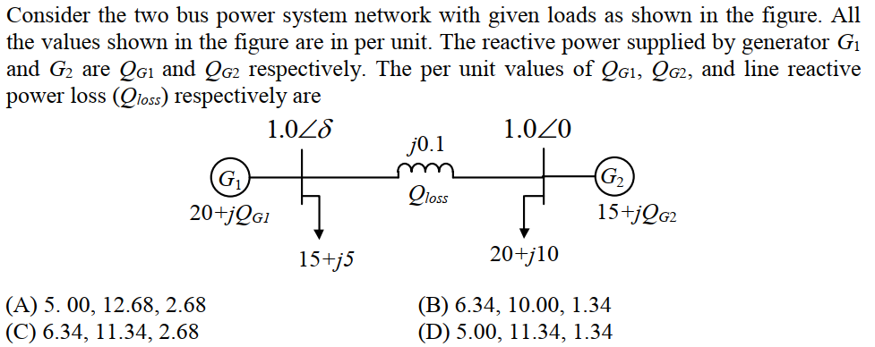

**6.GATE – 2018: 1 Marks**

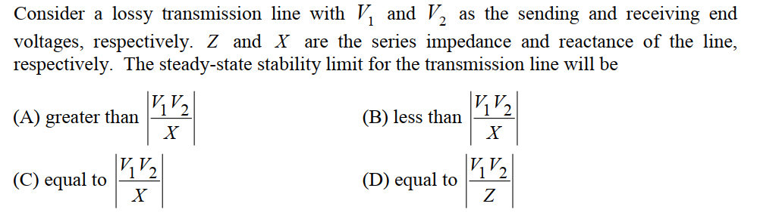

**7.GATE – 2018: 1 Marks**

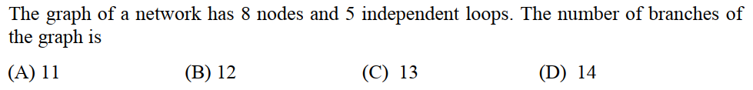

**8.GATE – 2016: 1 Marks**

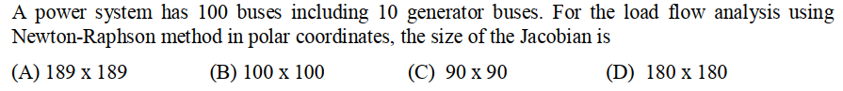

**9.IES – 2018**

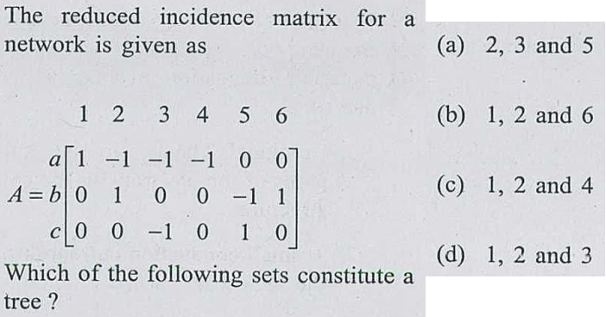

**10.IES – 2018**

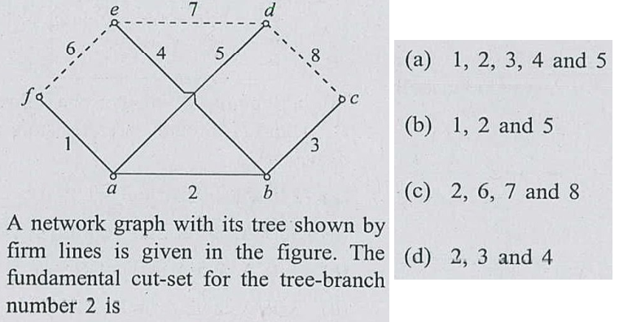

**11.IES – 2017**

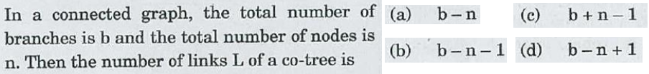

**Fill in the Blanks: (Minimum 10 to 15 with Answers)**

1.YBUS formula by using singular transformation method____________.

2. If a branch is added, then the dimensions of ZBUS will be changed or not.

3. If a link is added, then the dimensions of ZBUS will be changed or not.

.

**Unit-II:**

**Important points / Definitions: (Minimum 15 to 20 points covering complete topics in that unit)**

**Short Questions (minimum 10 previous JNTUH Questions – Year to be mentioned)**

**1.Define load bus and slack bus**

**2.Write short notes on PQ and PV buses**

**3.Which quantities are specified at slack bus?**

**4.Which quantities are specified at load bus?**

**5.What are the disadvantages of the Gauss Seidel Load Flow Analysis?**

**6.What is the advantage of using acceleration factor in Gauss-Seidel load flow method?**

**7.What are the advantages of conducting power flow studies?**

**8.What is the normal value of acceleration factor used in GS method?**

**9.A 12 bus Power System has three voltage-controlled buses. The dimensions of the Jacobean matrix will be?**

**10.In a load flow study, when PV bus is treated as PQ bus?**

**11.What is the Jacobean matrix?**

**12.What are the advantages of Newton Raphson Method?**

**Long Questions (minimum 10 previous JNTUH Questions – Year to be mentioned)**

**1.Explain the Derivation of Static load flow equations – Load flow solutions using Gauss Seidel Method?**

**2.Explain Load flow solution with and without P-V buses, Algorithm and Flowchart?**

**3.Explain the advantages and disadvantages of G-S method?**

**4.Compare G-S method and N-R methods.**

**5.Explain Newton Raphson Method in Rectangular and Polar Co-Ordinates Form?**

**6.Develop load flow equations suitable for solution by N-R method using rectangular Coordinates when only PQ buses are present**

**7.Explain Derivation of Jacobian Elements, Algorithm and Flowchart?**

**8.Explain Injected Active and Reactive Powers (Sample One Iteration only)?**

**9.Explain finding Line Flows/Losses for the given Bus Voltages?**

**Choose the Best: (Minimum 10 to 15 with Answers)**

1. At a slack bus the quantities specified are [ ]

a) P, Q b) P, |V| c) |V|, δ d) P, δ

2. Which of the following is true? [ ]

a) Gauss-Seidal method is a direct solution method of power flow

b) If the reactive generation exceeds the limit then the P, |V| bus will become a P,Q bus

c) A generator bus is also called a swing bus

d) All the above

**3.GATE – 2016: 1 Marks**

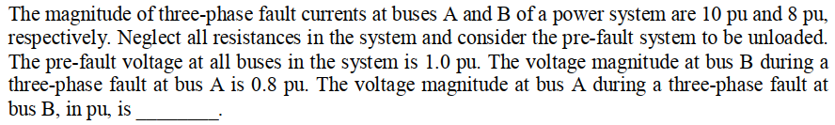

**4.GATE – 2016: 1 Marks**

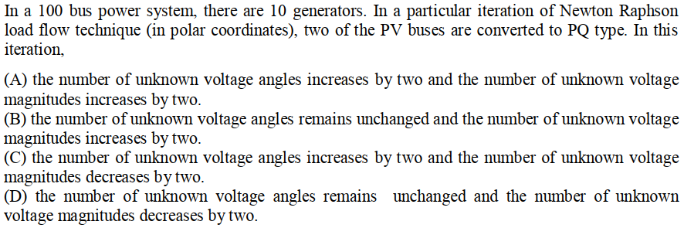

 5.**IES – 2018**

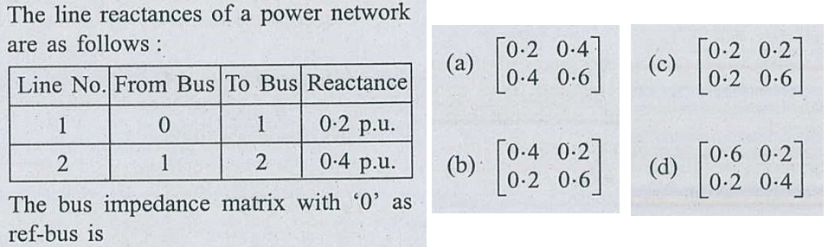

**Fill in the Blanks: (Minimum 10 to 15 with Answers)**

 1. The speed of fast decoupled load flow method when compared to Newton-Raphson method is

___________ times the N-R method speed per iteration.

2. The number of iteration required for an n-bus system in Newton-Raphson method are

approximately ______________

3. The number of iteration required for an n-bus system in Gauss-Seidal method are

approximately ________________

4. At a load bus the quantities specified are _____________

.

# 